BOOK REVIEW
By Dr Hannetjie Edeling 11 June 2020

- Title: Power vs Force – The Hidden Determinants of Human Behaviour
Author: David R Hawkins (1995, 1998, 2002)
2. Genre: Spirituality, Consciousness, Awareness, Kinesiology
- Is there a story to how you heard about the book or how you acquired it? Wayne Dyer talked about the book and I serendipitously found it in Colorado at a Michael Newton workshop in 2004. (This also links with the kinesiology demonstration in our firs session of this lockdown group).
- Central Premise: In our evolution as human beings we strive for growth, greater awareness and consciousness. The way to enhance one’s power in the world is by increasing one’s integrity, understanding and capacity for compassion and kindness. We need to realise that we are one and endeavour to choose and strive towards the positive rather than “fighting” for what is not desired. It is about taking responsibility for one’s growth by being mindful of one’s actions and their consequences (over lifetimes)
P.132. Power arises from meaning and has to do with motive and principle. It just “is” and does not move against anything at all. Force always moves against something and wants to “fight” for its position. It creates a polarizing counter-force and a win/lose dichotomy.

Best take-aways:
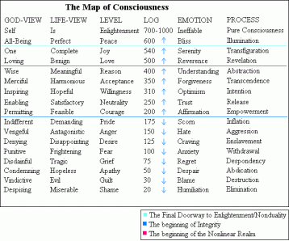
p. 75. An increase of even a few points represents a major advance in power – the rate of increase in power as we move up the scale is enormous.
p.76 – Levels below 200 are destructive and above 200 are constructive. p.112. Pain and suffering are associated with the lower levels.
An individual’s overall level of consciousness is the nett effect of these various levels.
P.101 Progression of Consciousness – 5 points per lifetime (p.235) unless real effort, choice and will are put into the process. People’s cumulative life choices can result in a net lowering of consciousness

p.34 – Explanation of Kinesiology: The human mind is like a computer terminal connected to a giant database
p.42. The body-mind connection. The mind “thinks” with the body itself. How consciousness affects body functioning and disease.
P 46 – Weak and strong attractors.
p.68 Map of consciousness and discussion
P.72. One can transcend the victim role – nothing out there has power over you – It’s how you react or what you think about what happens, that affects you.
Whenever force meets power, force is eventually defeated.
p.104-106 The “high” that people seek from substances is the suppression of the lower energy fields, with the result that they can experience their own higher levels of consciousness. A “high” is any state of consciousness above one’s customary level of awareness.

Ultimately (p141) we need to give up weak attractors for strong attractors.
p.167 – 169. Punishment or solutions that have power. (Away from vs towards motivation). Also p.221. When solutions are sought on the level of coercion, no peaceful resolutions are possible.

p.203, 204 – Surviving Success – p. 204 self vs Self

P. 146-147 - word lists that test above 200 and below 200

Q P. 149 (to read out) – Every word, deed and intention creates a permanent record.

Power in the marketplace: p. 163 Recognise the importance of feeling and of “family” for employees and customers.

Health, nutrition, humour, art, music, beauty, love, authenticity

To conclude: p.238 (read out) – 2 critical points that allow for major advancement – 200 and 500
p. 282 Counterbalancing negativity

Read more: Summary by RJ Banks

https://www.loaaffirmations.com/dr-david-hawkins--map-of-consciousness

